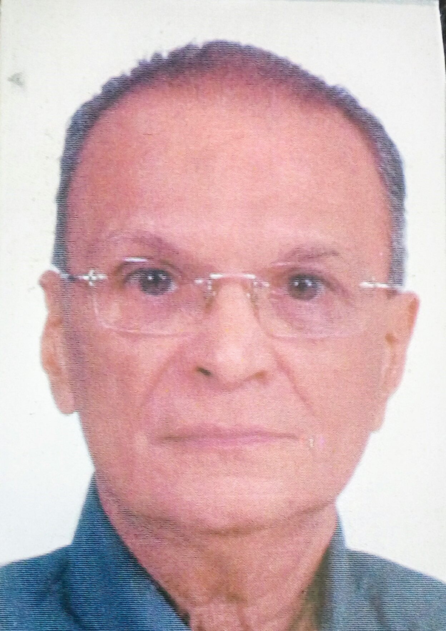

HARIN DALAL, _{Mech. & Computer Engineer}

TEL: +91 9987341998/ +91 8097041998
E-mail: harindalal40@gmail.com
GET BEST PRIVATE HOME TUITION
BY
QUALIFIED ENGINEER
WITH
20 YEARS IN PRIVATE INDIVIDUAL TUITION.
I WILL GUIDE THE STUDENTS FOR THEIR BRIGHT FUTURE.
I TEACH ENGLISH, MATHEMATICS, SCIENCE, EVS.

I HAVE BEEN TEACHING STUDENTS OF ALL BOARDS.
Till date, nearly 90 students have gained “A” GRADE.

THE CLASS WILL BE OF 90 MINS DAILY FOR 4 DAYS A WEEK.
MONTHLY FEE WILL BE PAID ON THE LAST DAY OF EVERY MONTH.
THE FEE WILL BE ON HOURLY BASIS

IF YOU ARE LOOKING FOR A MATURED, HIGHLY QUALIFIED, EXPERIENCED GURU, THEN JUST CALL ME FOR GUARANTEED BETTER RESULTS.

I ALSO TEACH LATEST COMPUTER PROGRAMS like ADOBE, AutoCAD, MAYA, REVIT, COREL, and MS OFFICE; MANY ARCHITECTS HAVE MASTERED THROUGH ME.

A PERONAL MEETING WILL HELP BOTH OF US TO KNOW EACH OTHER BETTER.
KRUSHNAY NAMH

